**Decoding Popularity**

**A Data-Driven Exploration of Spotify’s Top Hits in 2023**

Most Streamed Spotify Songs of 2023

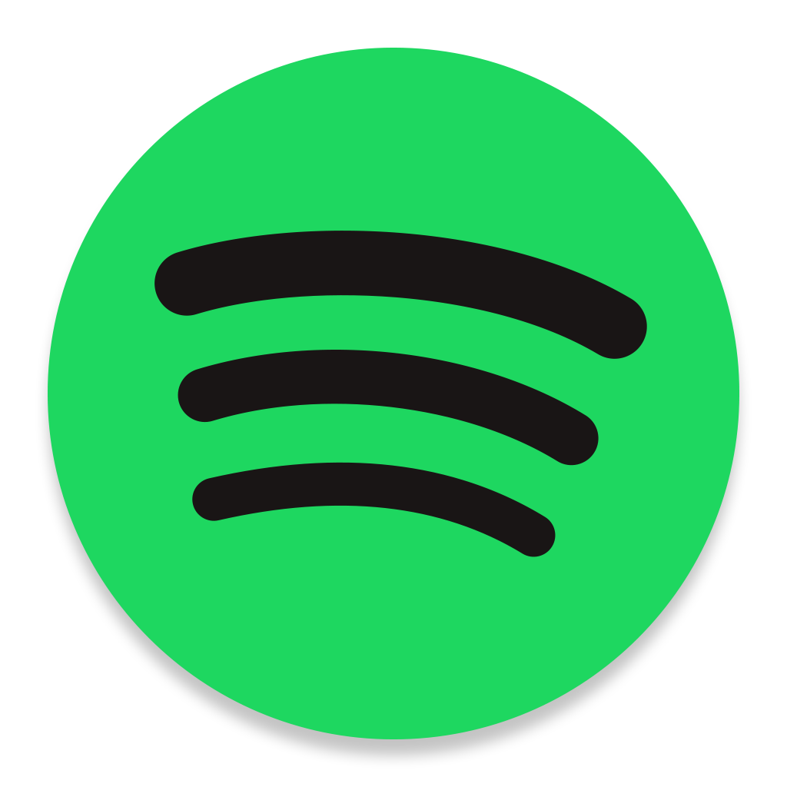

Analytical Sharks

Jayden Alvarez, Shreedhar Bhatt, Michael Herrera,

Rutvik Kachchhi, Francisco Padilla, and Robert Torres

**Introduction**

The rise of music streaming, led by major players like Spotify, has revolutionized the music industry. Streaming has become a fundamental aspect of how music is consumed and a significant source of revenue globally. This study focuses specifically on Spotify's influence, analyzing the Most Streamed Songs of 2023 to delve into the complexities of listener preferences and the factors that drive success in the era of music streaming. By integrating various analytical approaches, the aim is to capture the core trends of music streaming and provide insights into the future direction of music consumption.

**Spotify’s Era: Shaping the Music Streaming Revolution**

The music industry has seen a huge change with the rise of digital streaming services, especially with the rise of platforms like Spotify. Streaming has become a dominant mode of accessing and sharing music, accounting for 67% of the total global recorded music revenue in 2022, highlighting its immense popularity (Gotting, 2023). Spotify, a leading force in music streaming, has an impressive 551 million unique users as of 2023, along with a continually growing song library, making it a major player in the music industry (Iqbal, 2023). The platform not only provides a vast collection of global music but also enhances the listening experience with personalized features like Discover Weekly and curated playlists. Its data-driven approach offers valuable insights into listener preferences, influencing music trends and artist exposure. Despite facing challenges related to equitable royalty distribution and competition in the market, Spotify’s continual adaptation and technological advancements position it as a key player in the evolving music landscape. This dynamic context, encapsulating both the current trends and potential future developments, provides fertile ground for the study of the Most Streamed Spotify Songs of 2023.

**Forecasting Hits: Analyzing Trends in 2023’s Top Spotify Tracks**

The main objective of this study is to analyze and predict trends in the Most Streamed Spotify Songs of 2023, thereby gaining insights into listener preferences and factors influencing song popularity in the digital music era. This study comprises of two main components:

1. Analytical Exploration: Creation of an interactive dashboard to visualize key data points such as streaming counts, audio features, and artist information. This aims to offer a clear understanding of the characteristics of popular songs in 2023.
2. Predictive Analysis: Investigation of factors affecting a song’s success on Spotify. This includes examining the impact of release timing, artist count, and specific audio features like danceability, energy, liveness and speechiness from various songs. The objective is to identify patterns and predictors of hit songs, contributing to a broader understanding of how digital platforms shape musical tastes.

By merging descriptive insights with predictive analytics, the research seeks to not only illuminate the current state of music streaming but also anticipate future trends in song popularity.

**Streaming in Focus: Dynamics and Trends Shaping Music in 2023**

In 2023 the music streaming industry, expected to be worth $330 billion, is transforming through technological advancements and changing user behaviors (Adebisi, 2023). Spotify has introduced new features like Smart Shuffle and dynamic interface, which have improved user interaction and personalized the music discovery experience (Giandurco, 2023). Artificial Intelligence and Machine Learning play a crucial role in enhancing streaming experiences with advanced recommendation algorithms and improved user experiences (Kaput, 2022). The industry's growth is marked by an unprecedented 1 trillion streams in a quarter, showcasing the rise of diverse genres like Latin and K-pop (Sherman, 2023). The streaming audience, now exceeding 400 million, primarily aged 18-24, favors mobile and premium services, with average weekly streaming exceeding 19 hours on platforms like Apple Music and Spotify. This underscores the significant role of streaming in daily life (Tiushka, 2023; Adebisi, 2023).

These trends and advancements are vital for our study, providing key data for our analytical dashboard and predictive analysis. The data from 2023 allows for analyzing streaming patterns and song characteristics and understanding factors like release timing and artist collaboration that drive a song’s success. This analysis is crucial for comprehending current song popularity dynamics and evolving listener preferences.

**Methods**

**Dataset and Variable Overview**

The dataset for this study features the Most Streamed Songs on Spotify for the year 2023, sourced from Kaggle with 924 songs. It includes essential data such as track names, artist names, streaming counts, and release dates, alongside various audio features like danceability, energy, and liveness. This dataset is pivotal for analyzing the latest trends in music streaming and understanding what drives song popularity.

**Variable Measurement and Scaling**

In this study, we analyzed key variables from the Spotify dataset, including Track Name and Artist Name for track identification and qualitative analysis; Artist Count, a numerical indicator of collaboration; Release Year, Month, and Day, to assess timing trends in song popularity; Streams, our main measure of popularity; and Audio Features, which quantify musical characteristics to explore their relationship with streaming success.

**Descriptive Statistical Analysis and Data Visualization**

* Descriptive Statistics: Provides a statistical summary for the dataset’s key variables.
* Day-of-the-Month Distribution: Depicts the frequency of song releases across different days of the month.
* Monthly Distribution: Displays the total number of song releases for each month.
* Frequency of Songs by Number of Contributing Artists: Shows the distribution of song counts based on the number of contributing artists.
* Average Audio Feature Values: Compass the mean values of different audio features within the dataset.
* Streams Distribution by Release Month: Visualizes the spread of streams for songs released in different months.
* Average Streams per Month: Illustrates the mean stream count for each month.
* Histogram of Danceability and Energy: Presents the frequency distribution of ‘Danceability’ and ‘Energy’ values in the songs.
* Distribution of Streams: Portrays the frequency distribution of stream counts for songs.
* The Weeknd - Blinding Lights: Compares the playlist inclusion count for “Blinding Lights” on Spotify and Apple Music.

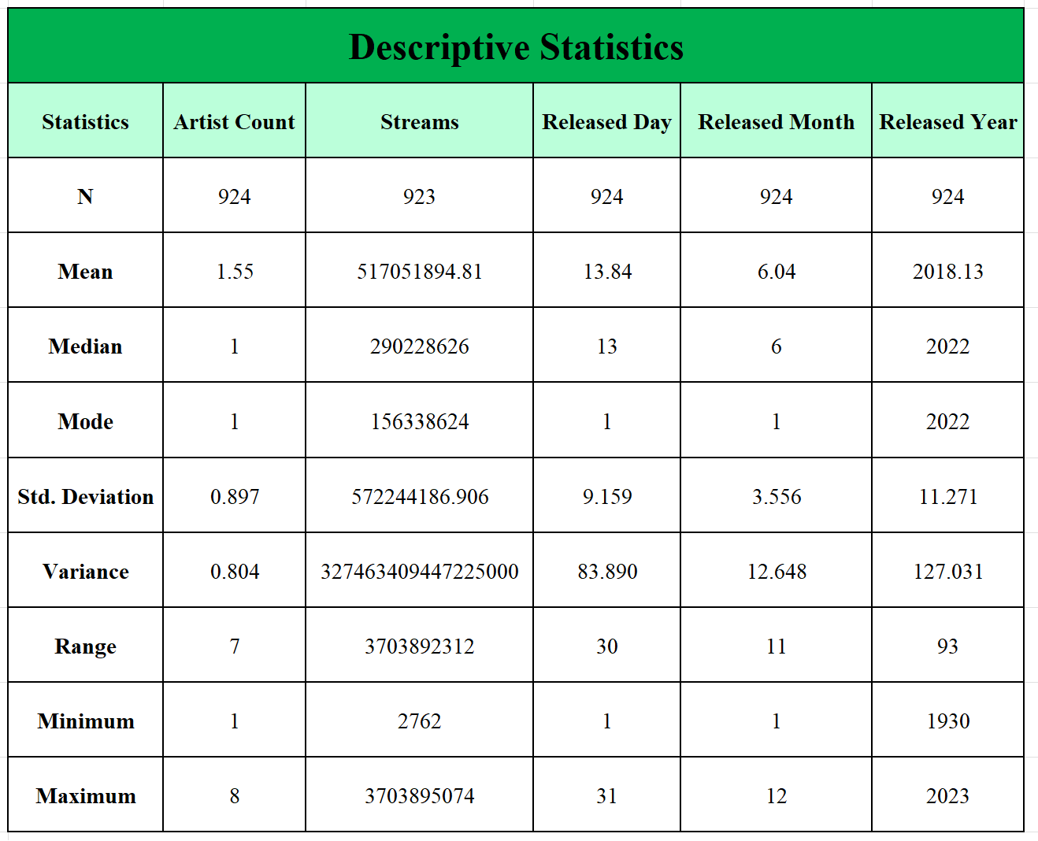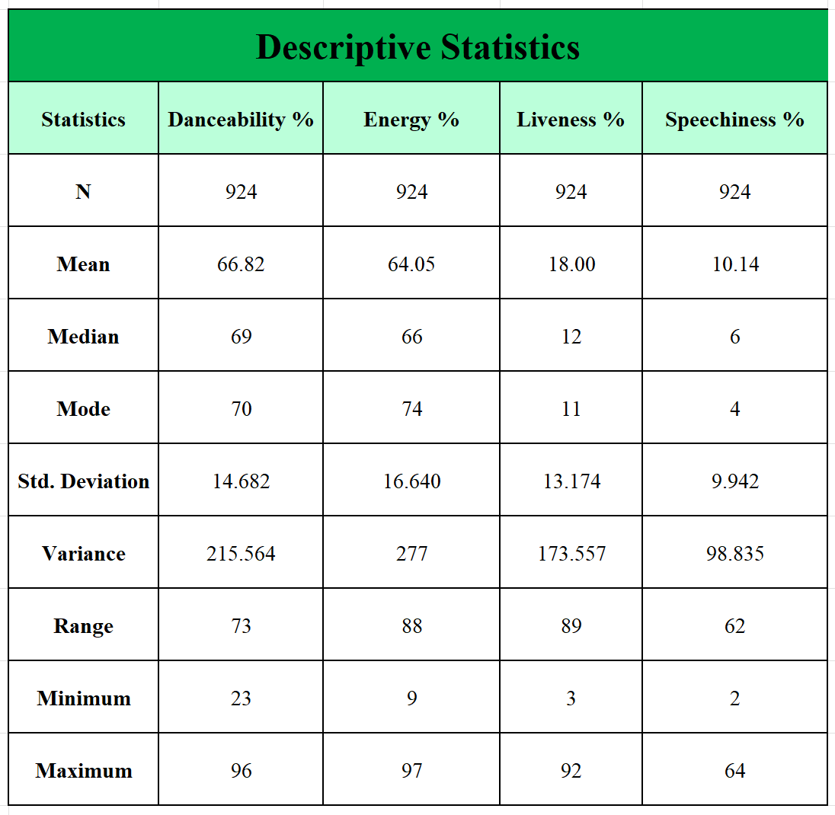

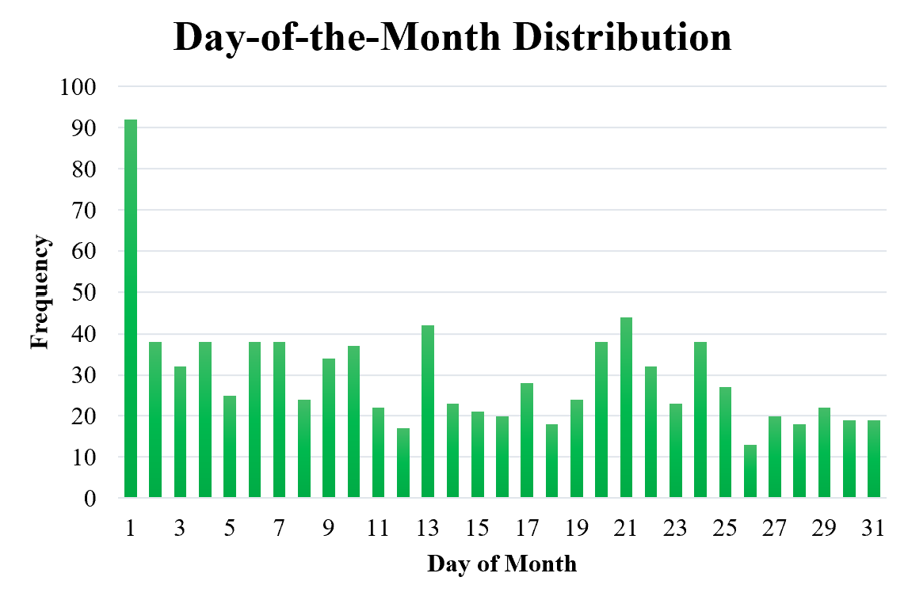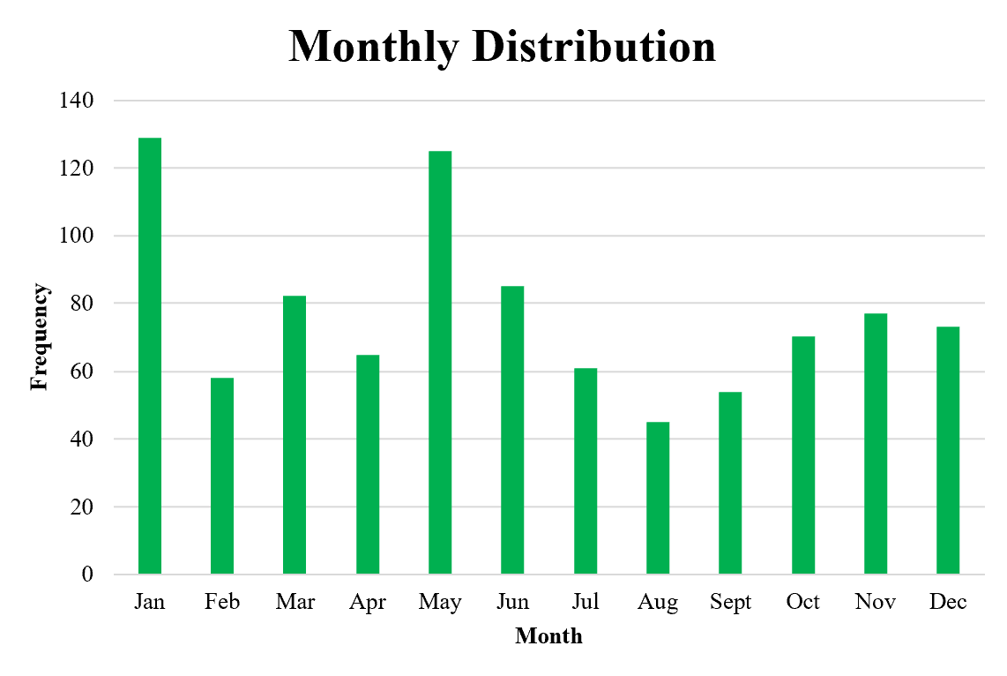

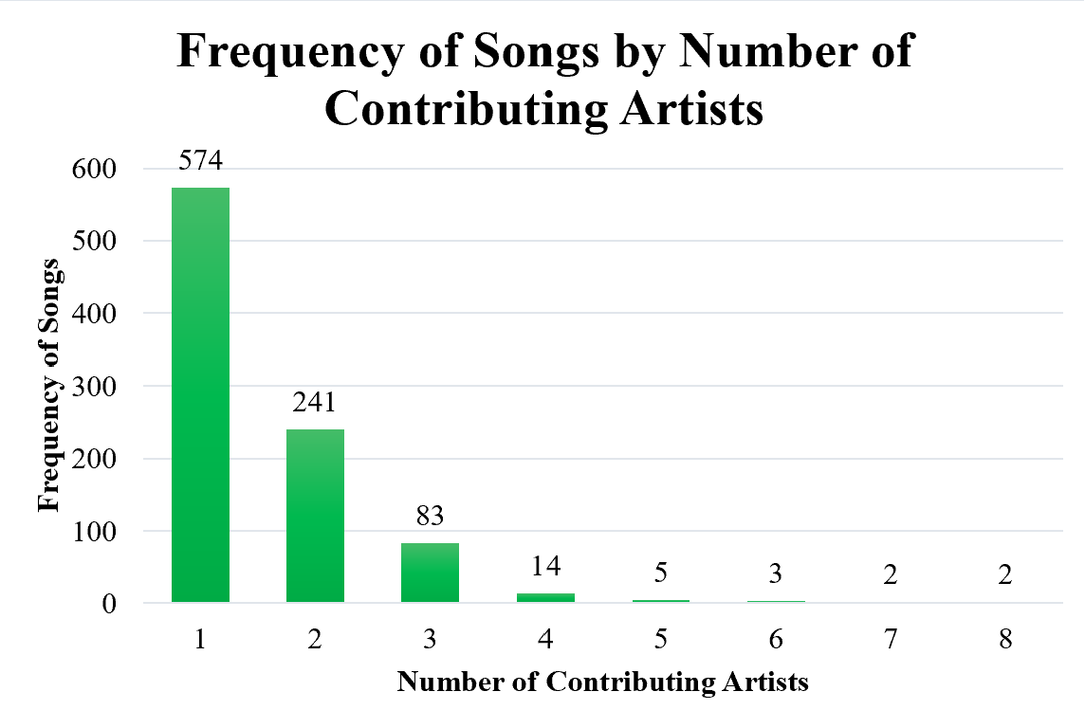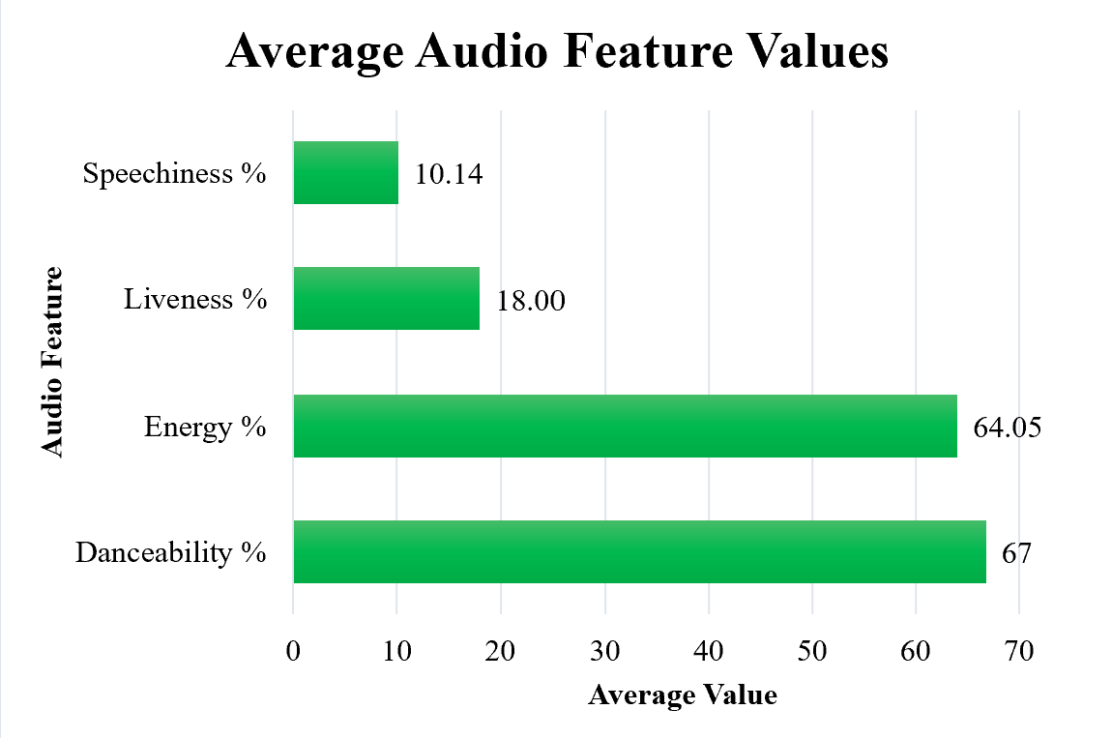

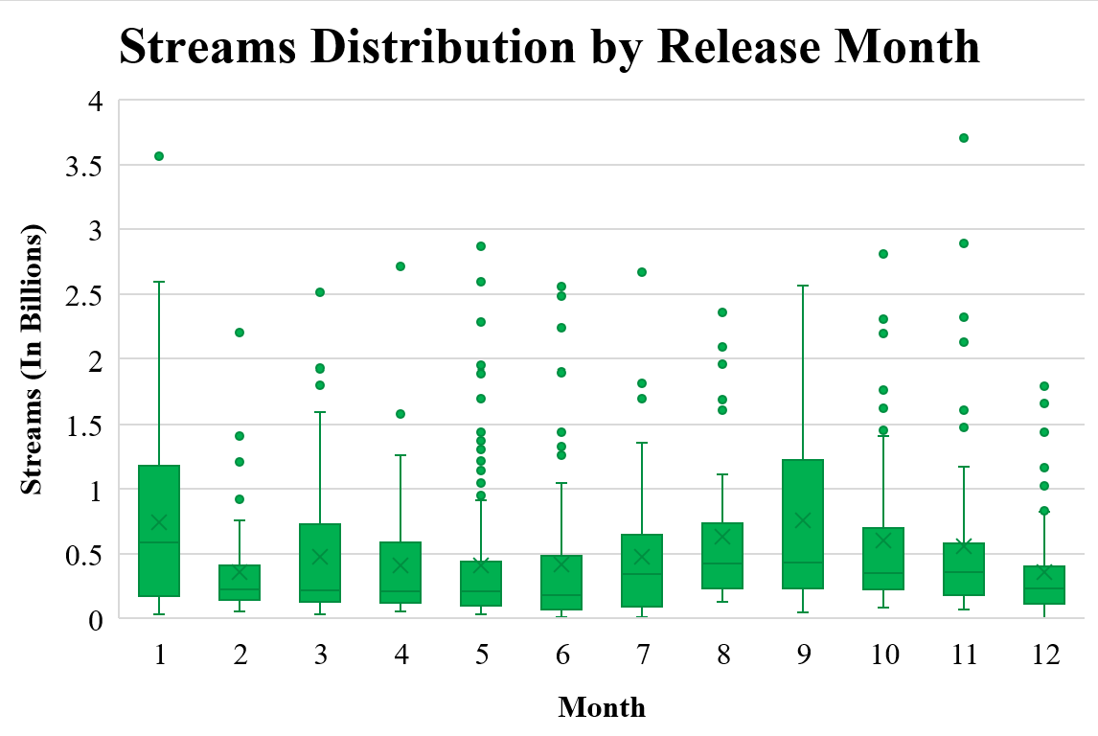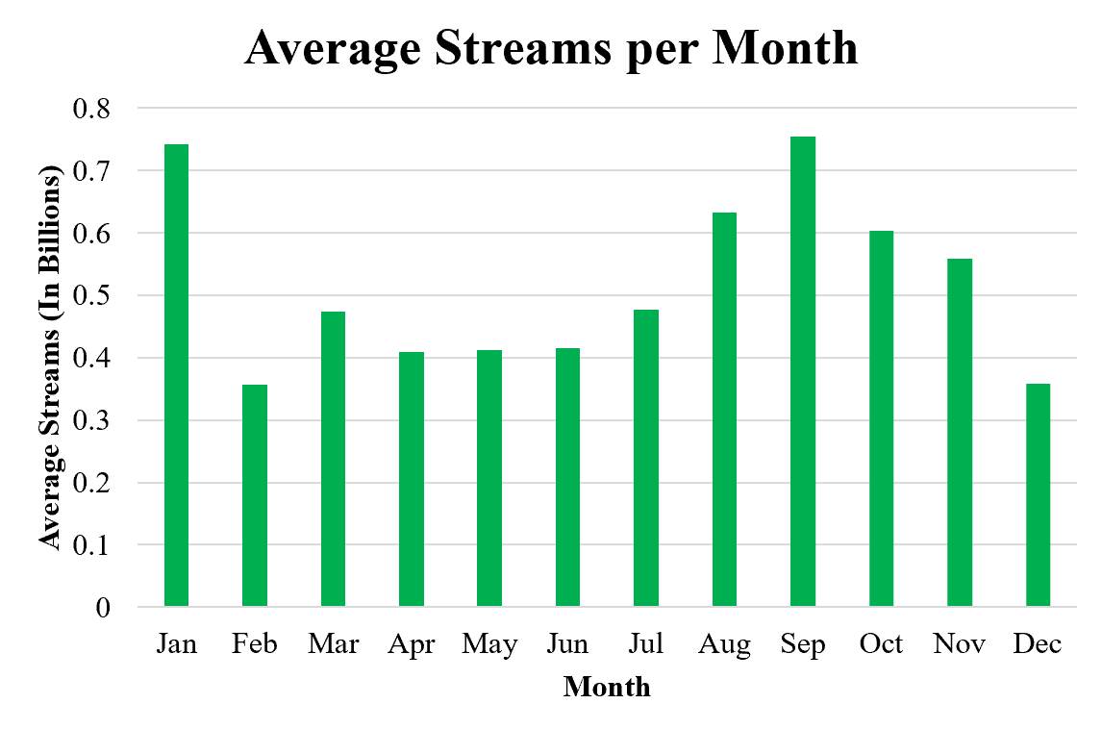

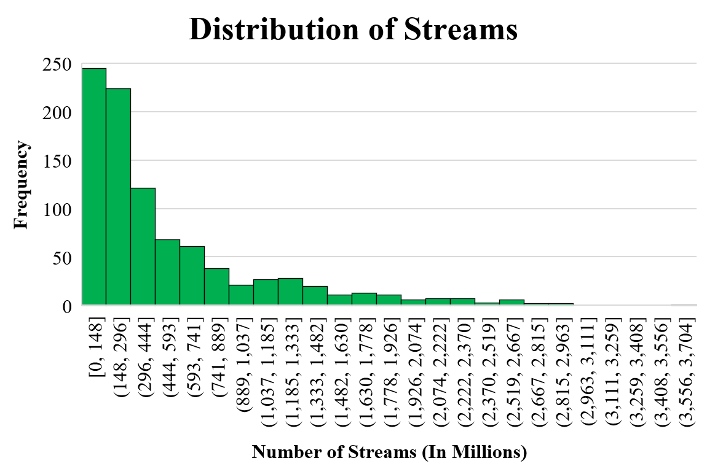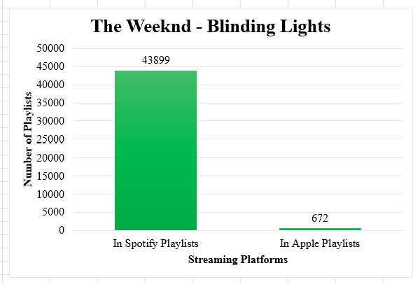

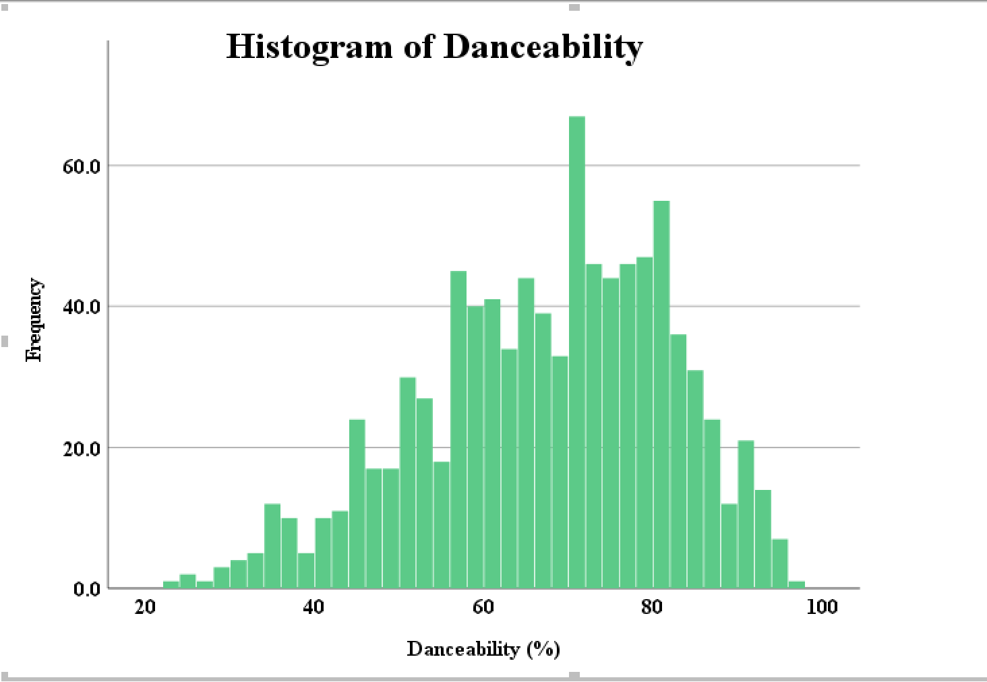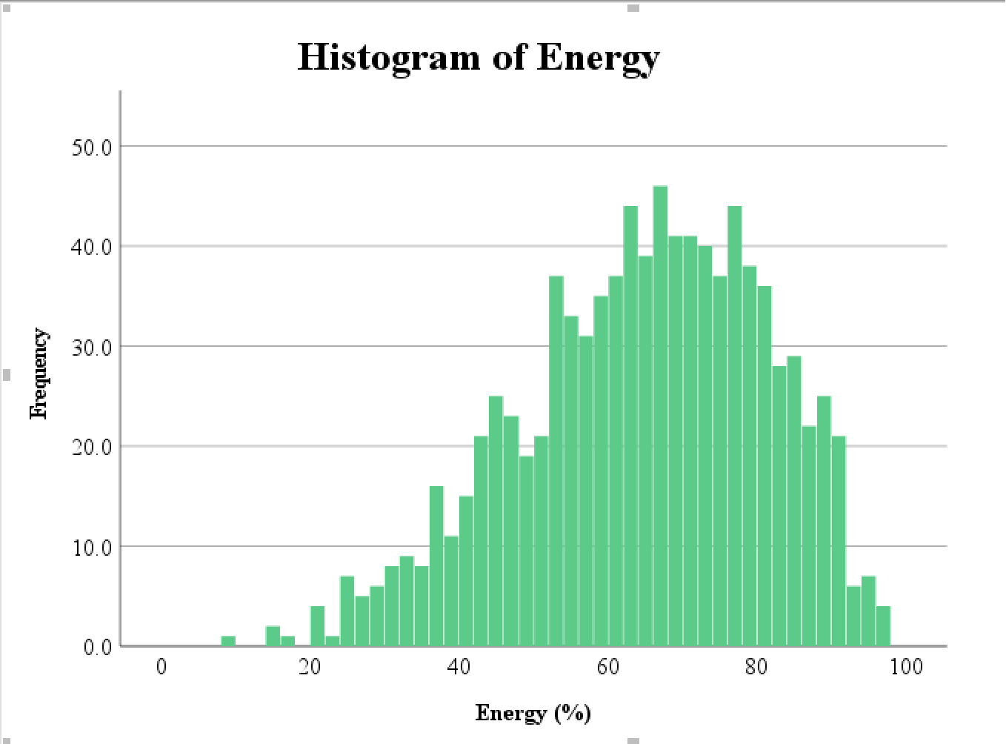

**Methodology for Analytical Deep Dive into Streaming Data**

Leveraging SPSS, we conducted a linear regression model to investigate how various factors influence streaming numbers. This approach allowed us to quantify the impact of different variables on the popularity of Spotify’s Most Streamed Songs in 2023.

***Types of Data and Sources:***

Our analysis leverages a dataset from Kaggle, comprising Spotify’s Most Streamed Songs of 2023. This dataset, previously detailed, includes key quantitative and categorical variables like streaming counts, artist details, release dates, and audio features. Chosen for its comprehensive coverage, it provides the necessary data to examine the factors influencing song popularity on Spotify, aligning with our studies aims.

***Data Cleaning and Preprocessing Steps:***

The initial stage of preparing the Spotify Dataset involves a thorough cleaning process where duplicate records were purged, correcting inaccuracies, and applying consistent data formatting. When encountering miss data, entries were either removed or dealt with in a manner that struck a balance between preserving the dataset’s integrity and keeping it comprehensive. To ready the data for linear regression analysis, preprocessing steps such as normalization and transformation were applied to align the dataset with the requirements of the regression model.

*Power BI Dashboard Design for Spotify 2023*

1. Data Import and Cleaning: Data was imported from Excel into Power BI, where special characters and null values were removed, and dates were standardized using Bravo.
2. Dashboard Elements: The header includes the Spotify logo and a reset button. Slicers for Track, Date, Artist, and Year enable dynamic data exploration.
3. Visualizations: Bar and line charts illustrate track popularity and release patterns. Cards display average streams and track performance comparisons.
4. Music Data and Charts: Two sections categorize track details and audio features. Heatmaps and energy charts offer thematic insights into the data.
5. Interactive Features: HTML 5 visuals display artist images with suitable CSS styling for aesthetic consistency.
6. References: This preparation was informed by insights and methods adapted from various resources, including a Stack Overflow discussion on converting Vega Deneb gauges for Power BI (Stack Overflow), Deneb templates for thematic heatmaps (PowerBI-tips), and a color palette from Color Hex to visually enhance the dashboard’s design (Color Hex).

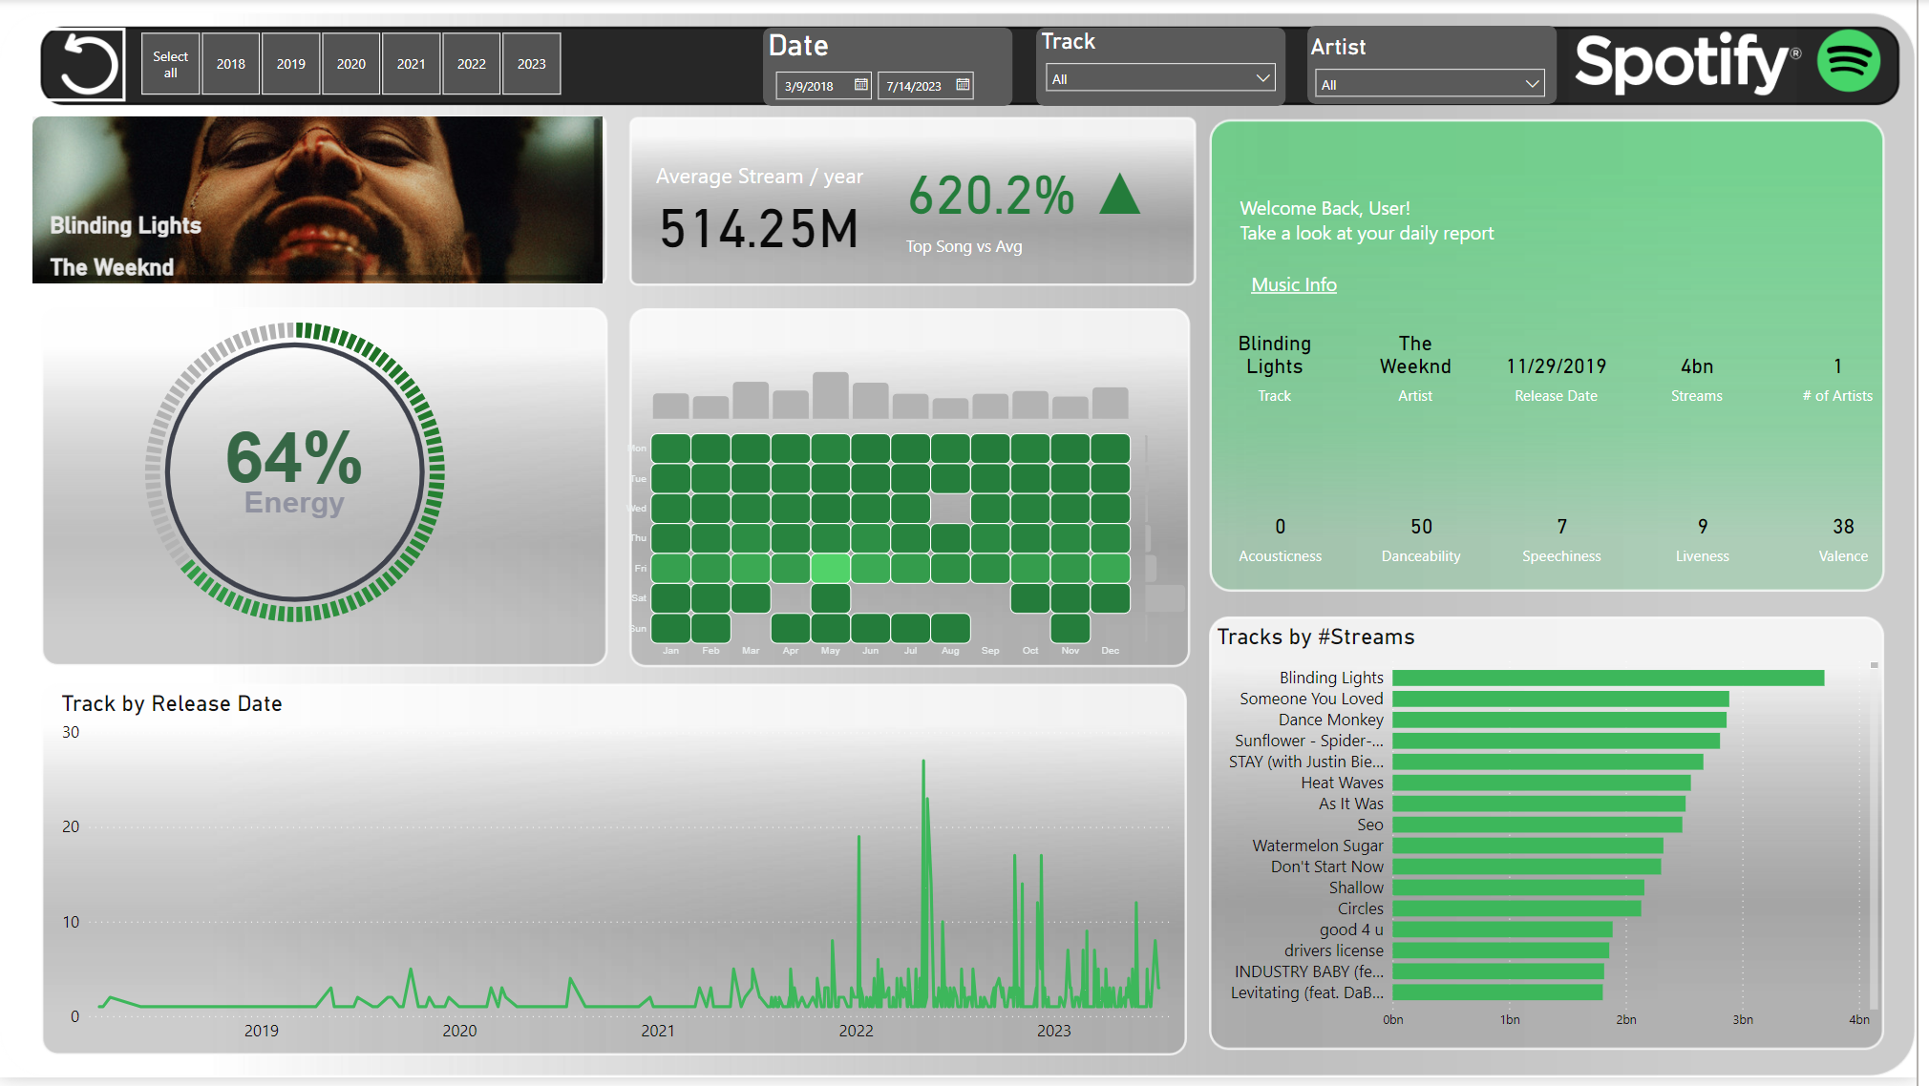

***Description of the Linear Regression Model:***

In our study, we used a linear regression model to analyze the influences of various factors on the streaming number of Spotify’s Most Streamed Songs in 2023. Linear regression was chosen for its efficiency in identifying and quantifying the relationships between a dependent variable and multiple independent variables. Our model is structured as follows:

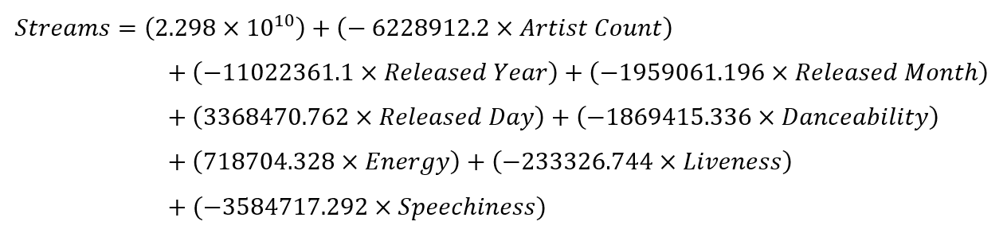

The constant term represents the estimated number of streams when all the independent variables are set to zero. Each coefficient reflects the estimated change in the number of streams associated with a one-unit change in the respective predictor variable, holding all other variables constant. The independent variables were chosen based on their potential relevance to streaming popularity: Artist Count, Release Timing (Year, Month, Day), and Audio Features (Danceability %, Energy %, Liveness %, and Speechiness %).

***Assumptions and Limitations of the Chosen Method:***

Our regression model assumes linearity, independence, and equal variance among residuals. Our analysis is based on a single year and platform, which may not reflect wider industry trends. Caution should be exercised when generalizing these results beyond the scope of Spotify’s 2023 streaming data.

**Results**

This section unveils the key findings derived from the analysis, with an emphasis on presenting the results objectively without delving into broader interpretations. Included are relevant coefficients from the regression model, shedding light on their statistical significance.

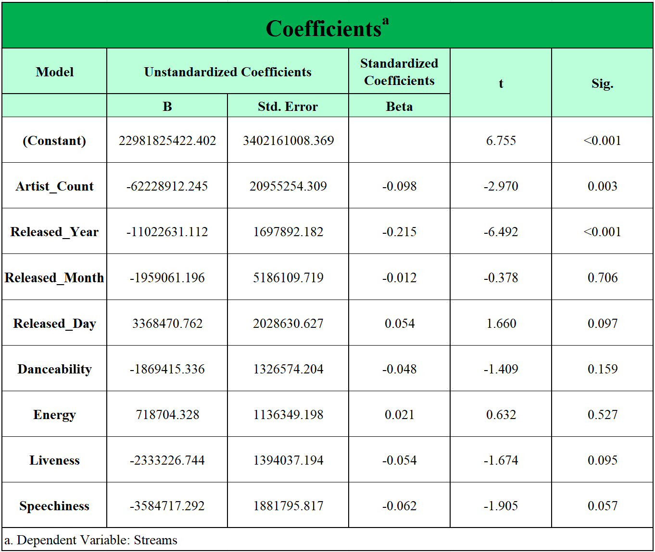

A detailed summary of each independent variable (IV) is provided below:

1. **Constant (Intercept):** This is the expected mean value of the dependent variables (Streams) when all independent variables are set to zero. The significant p-value indicates that the model intercept is statistically significant.
2. **Artist_Count:** The negative coefficient suggests that, on average, an increase in the number of artists involved in a song is associated with a decrease in a number of streams. Its significance (p = 0.003) suggests that this relationship is statistically significant and unlikely to be due to random chance.
3. **Released_Year:** The negative coefficient indicates that songs released in later years tend to have fewer streams. Given its significance (p < 0.001), this is a strong predictor in the model.
4. **Released_Month:** The coefficient for Released_Month is not statistically significant (p = 0.706), indicating that it is ineffective in predicting the number of streams for a song.
5. **Released_Day:** Released_Day shows a trend towards significance (p = 0.097), which is just below the conventional 95% threshold. This suggests a possible relationship with streams that may not be robust.
6. **Danceability:** Danceability has a p-value of 0.159, which is above the 0.05 threshold for statistical significance, suggesting that its predictive power may not be reliable. However, due to its comparatively minimal impact on the dependent variable, it should be considered cautiously in subsequent analyses.
7. **Energy:** The coefficient for Energy is not statistically significant (p = 0.527), indicating that it is ineffective in predicting the number of streams for a song.
8. **Liveness:** Similar to Released_Day, shows a trend towards significance (p = 0.095). However, given its limited effect on streaming outcomes, it is advisable to exclude it from subsequent analyses.
9. **Speechiness:** Speechiness has a p-value of 0.057, which is slightly above the conventional threshold for significance, indicating a potential but not definitive negative relationship with streams.

**Note**: Consideration of confidence levels and effect sizes is vital in determining the suitability of each variable for subsequent analyses and business implications.

**Discussion**

**Interpreting the Results**

Our study’s findings explain significant features of Spotify’s influence on music streaming trends in 2023. One noteworthy discovery is that songs with fewer artists tend to be more popular on Spotify, as indicated by the negative coefficient for Artist count. This suggests that Spotify users might prefer solo artists or smaller collaborations. This could be due to a variety of things such as users appreciating clearer brand identity in their style of music or simpler music styles. Our findings also challenge the traditional thinking in the music industry about how important the release month is for a song’s success in streaming. It turns out that the timing of a song’s release might not be as critical as we once believed.

**Significance of Variables**

The analysis reveals that the Energy variable does not significantly affect streaming numbers, which may suggest a broader spectrum of listener preferences on Spotify. This challenges the common assumption that high-energy tracks are universally preferred, highlighting the platform's potential to cater to diverse tastes across different genres and moods. Additionally, while Speechiness shows a trend towards a negative correlation with streams, it does not reach the conventional threshold for statistical significance (p < 0.05). This tentative association warrants further investigation, as it could imply a shifting listener preference toward music that serves as a backdrop for other activities, favoring instrumental or less lyrically intensive tracks. Such trends underscore the complex nature of musical preferences in the streaming era and signal the need for a nuanced approach to understanding what drives listener engagement on digital platforms.

**Trends and Comparisons**

The data suggests a notable trend: songs released in more recent years tend to have fewer streams. This could be indicative of changing patterns in music consumption or perhaps a reflection of an increasingly saturated market. These findings echo those of other research, which has hinted at a gradual evolution in the discovery and consumption of new music within the streaming era. In light of our study, it may be worth reconsidering the emphasis traditionally placed on the timing of music releases. While our analysis does not find a significant impact of release month on streaming numbers, this should not be interpreted as conclusive evidence that release timing is no longer relevant. Rather, it may suggest that factors such as release timing could be interacting with other variables in complex ways that our study has not fully captured. This nuanced view aligns with a broader observation: platforms like Spotify might be altering the landscape of music promotion, placing a greater emphasis on the intrinsic appeal of the music and artists themselves over established marketing strategies. Nevertheless, these insights should be seen as preliminary, inviting further investigation into how digital platforms are reshaping the music industry.

**Real-World Applications**

The findings of our study offer actionable insights for artists and record labels aiming to optimize their release strategies on Spotify. The significant impact of artist count on streaming success underscores the importance of understanding listener preferences in relation to collaborative versus solo tracks. Record labels might consider these insights to fine-tune their promotional tactics and better align with observable trends. Additionally, these results could inform Spotify and similar platforms in refining their recommendation algorithms to better match user preferences. Marketing teams could leverage this information to adapt their strategies, potentially focusing on aspects that resonate with the audience. However, it is crucial to acknowledge that these insights are drawn from a single year's data and may not encapsulate all the intricacies of the platform's algorithm or the full scope of listener behavior. Therefore, while these insights are informative, they should be integrated with caution and in conjunction with other data sources and market knowledge.

**Limitations and Future Research**

Our study, while insightful, is limited by its focus on single year’s data from only Spotify, potentially overlooking longer-term trends and variations across different streaming platforms. Relying heavily on quantitative data can lead us to overlook the qualitative elements that help us understand why certain music trends come about. Future research should extend over multiple years and include diverse streaming services to capture a broader picture of the music streaming landscape. Incorporating qualitative methods, such as user interviews, could uncover deeper motivations behind streaming choices. Additionally, exploring the influence of Spotify’s algorithms and playlists on music popularity would provide valuable insights into the digital music ecosystem.

**Conclusion**

In conclusion, this exploration into Spotify’s top hits of 2023 reveals significant insights into the factors influencing song popularity in the digital age. Our analysis indicates that there are a variety of factors that can influence the popularity of a song including:

* **Artist Count:** A significant finding is that a higher number of artists on a song correlates with fewer streams. This suggests a preference among Spotify users for solo artists or smaller collaborations.
* **Release Year:** The analysis indicated a significant correlation between release year and number of streams. The songs released in later years were shown to have fewer streams. This trend may reflect evolving music consumption habits or market saturation.
* **Release Day and Liveness:** Our analysis did not find these variables to significantly impact streaming numbers. These challenges some common assumptions in the music industry about the importance of specific release days and the role of liveness in streaming success.
* **Other Variables (Release Month, Danceability, Energy, and Speechiness):** The remaining variables that we tested, release month, danceability, energy, and speechiness, showed to be insignificant, indicating no significant influence on the number of streams.

These findings not only enhance our understanding of music streaming dynamics but also offer practical guidance for industry stakeholders seeking to optimize their digital presence. While mindful of its limitations, such as accounting for only single year data instead of long-term data, ignoring the data from other streaming platforms, and overlooking possible qualitative elements, this study lays groundwork for future research. These limitations pose new research opportunities, delving into more broad and diverse data gathering such as streaming numbers from several other streaming platforms, historical streaming data, and incorporating qualitative methods. As the digital music landscape continues to evolve, studies like ours become pivotal in identifying the elements of success in an increasingly competitive market.

**References**

Adebist, A.A. (2023, June 30). *Music Streaming Services Statistics 2023: Trends, Revenue,*

*Usage, and Market Forecast*. Gadget Advisor. Retrieved from

<https://gadgetadvisor.com/guides/music-streaming-services-statistics-2023-trends-revenue-usage-and-market-forecast/>

Color Hex (n.d.) *Color Palette 53188*. Retrieved from

<https://www.color-hex.com/color-palette/53188>

Giandurco, J. (2023, March 15). *Spotify’s New 2023 Updates: Smart Shuffle, An AI DJ, & More.*

Bustle. Retrieved from <https://www.bustle.com/life/spotify-updates-2023-smart-shuffle-discovery-mode-dj>

Gotting, M.C. (2023, September 26). *Music Streaming Revenue Worldwide from 2005 to 2022*.

Statista. Retrieved from

<https://www.statista.com/statistics/587216/music-streaming-revenue/>

Iqbal, M. (2023, August 2). Spotify Revenue and Usage Statistics (2023). Business of Apps.

Retrieved from <https://www.businessofapps.com/data/spotify-statistics/>

Kaput, M. (2022, September 19). *How Spotify Uses Artificial Intelligence - and What You Can*

*Learn from It.* Marketing AI Institute. Retrieved from <https://www.marketingaiinstitute.com/blog/spotify-artificial-intelligence>

PowerBI-Tip (n.d.). *Heatmap with bars - red themed [Code]*. Retrieved from

<https://github.com/PowerBI-tips/Deneb-Templates/blob/main/templates/heatmap%20with%20bars%20-%20red%20themed.json>

Sherman, M. (2023, July 12). *Music streams for 2023 hit 1 trillion in record time. Latin and*

*K-pop…*AP News. Retrieved from <https://apnews.com/article/luminate-midyear-music-report-2023-7534c1506d8c9565168b37b635f76c8b>

Stack Overflow. (n.d.) *Convert Vega Deneb gauge to work in PowerBI*. Retrieved from

<https://stackoverflow.com/questions/75881301/convert-vega-deneb-gauge-to-work-in-powerbi>

Tiushka, N. (2023, September). *130+ Music Streaming Statistics: User Demographics, Industry*

*Market, Revenue.* MarketSplash. Retrieved from <https://marketsplash.com/music-streaming-statistics/>